AgentStudio Quick start
  - Steps:
- Clone
git clone https://github.com/NetApp-Nemo/AgentStudio.git
- Build
make docker-build-push && make images-build-push && make workers-build-push
- Local K8s cluster setup
Docker desktop -> Kubernetes -> Create cluster
Provide as much resources as possible
E.g. on M3 Macbook pro: 12 CPU, 25 Gi RAM, 170 GB Disk
- Deploy agentstudio locally
OBSERVABILITY=1 make deploy-all FORCE_PULL=1 HELM_EXTRA_ARGS="-f ~/galactica/deployments/helm/nemo/values-resource-constrained.yaml"
- Setup local DNS
$ sudo vim /etc/hosts

Add these to end of file:

127.0.0.1 agentstudio.local
127.0.0.1 app.agentstudio.local
127.0.0.1 s3.agentstudio.local
127.0.0.1 auth.agentstudio.local
127.0.0.1 catalog.agentstudio.local
127.0.0.1 workflows.agentstudio.local
127.0.0.1 phoenix.agentstudio.local
127.0.0.1 grafana.agentstudio.local
- Visit console
https://app.agentstudio.local:8443/console/
- First login setup
First login will show a welcome page with instruction to setup KeyCloak, navigate and follow instructions
  - Setup
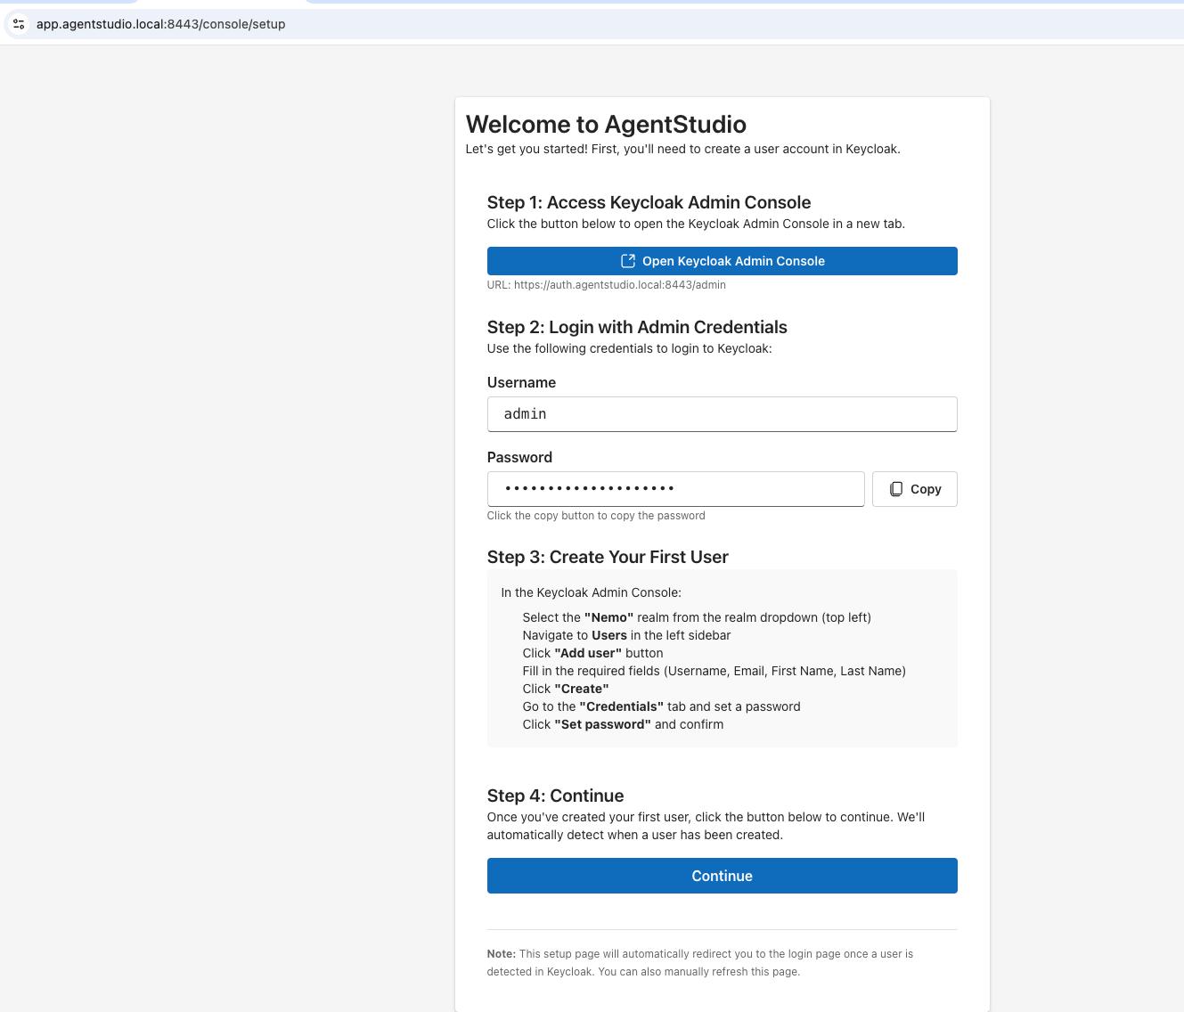

- Once you login to the keycloak as admin, switch realm to nemo, and add user(s), set their credentials.
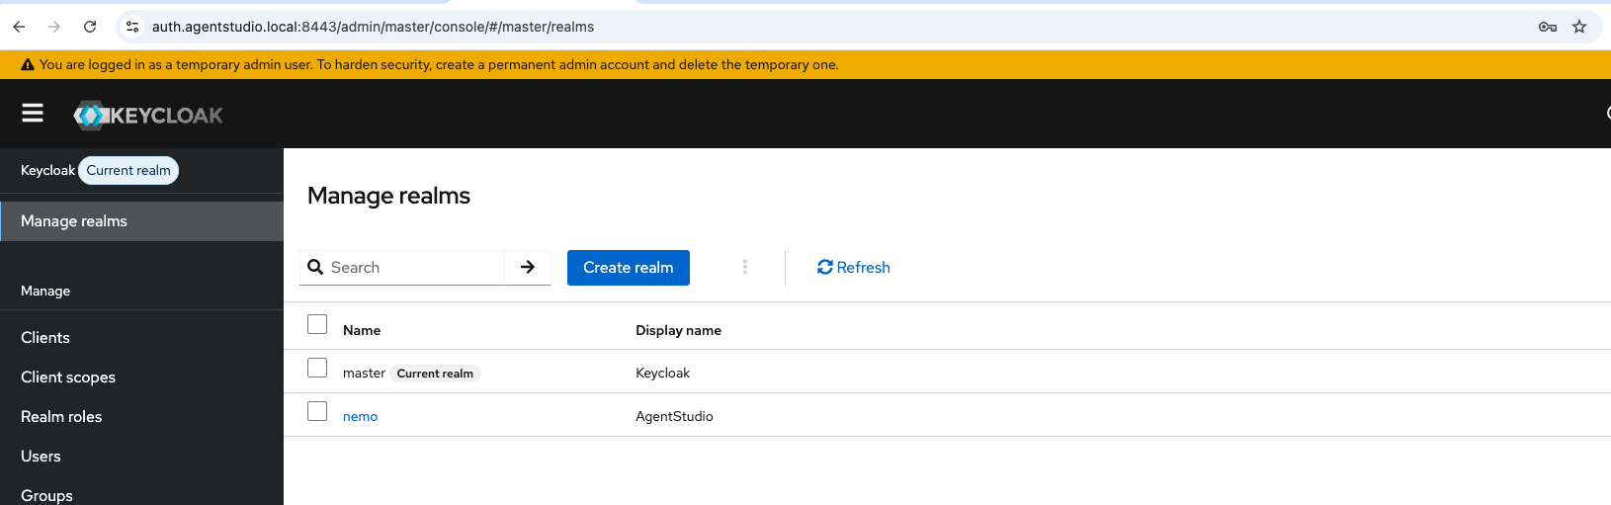
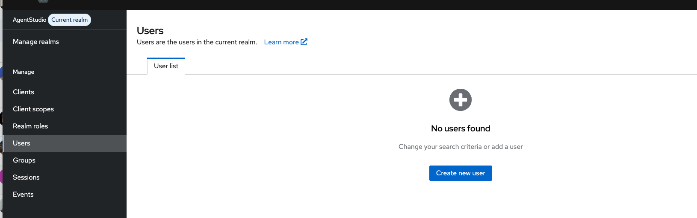
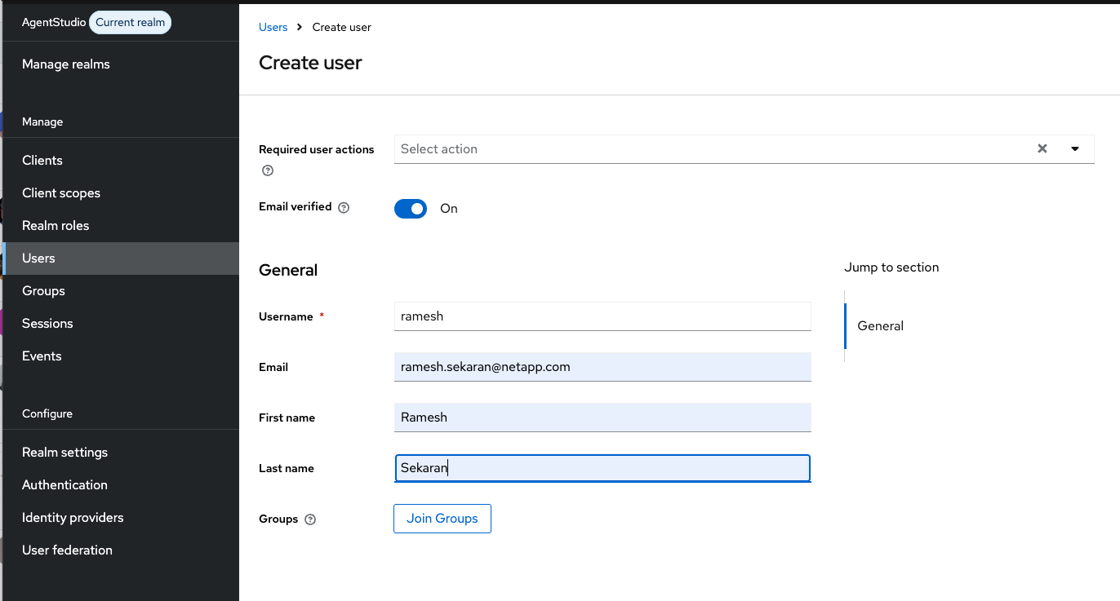
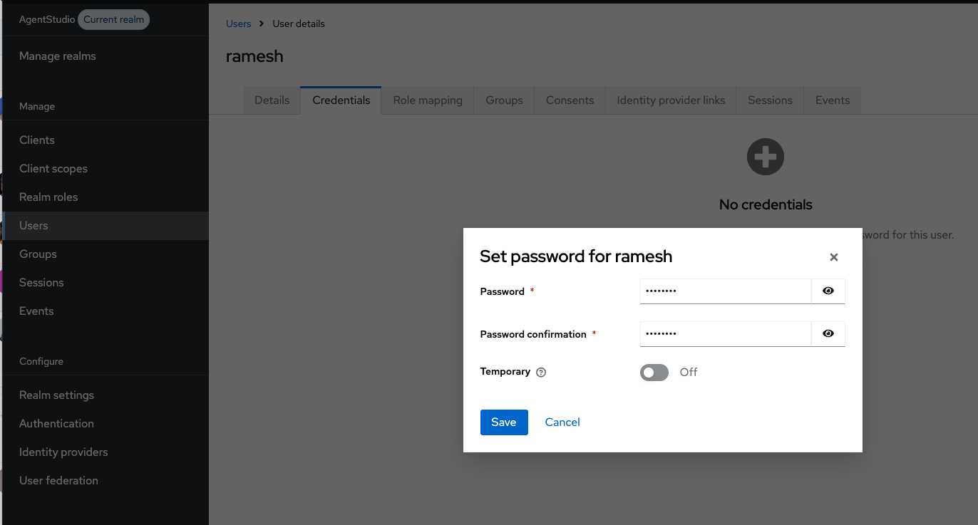

  - Login
- With at least one user configured, AgentStudio screen will auto redirect to login screen

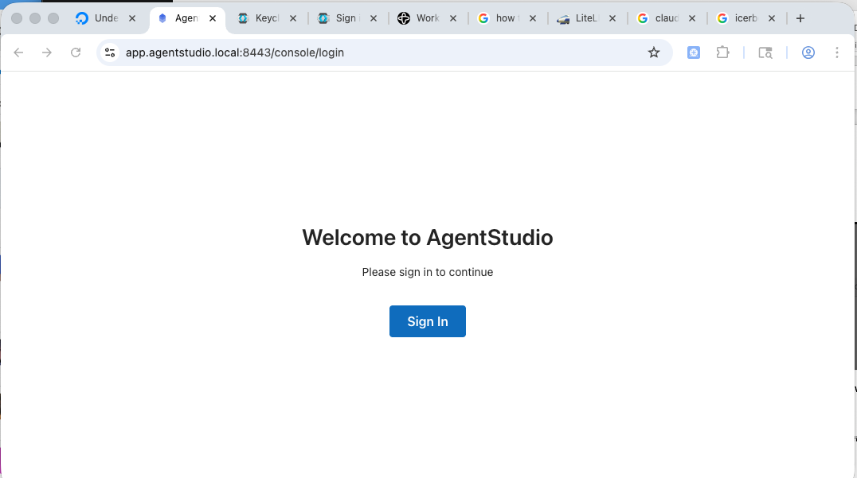

  - Home page
- Signin and you can create projects
